Noah Baugh

Prof. Muhammad

Data110, CRN 22016

Prescription data are available for this project, dealing with the age of the patient, medication duration, and the total dose of opioids. This dataset has been selected based on the growing concern about opioid prescriptions in healthcare and its implications for patient management and public health. These will be important to understand the trends between patient demographics, medication duration, and opioid dosage, which has great implications for prescribing practices and, therefore, future treatment strategies.

The process of exploratory data analysis involved several steps, as shall be discussed below.

1. Cleaning and Preparation of Data: First, the dataset was cleaned for any missing values and inconsistencies. Checks were also conducted for data types to ensure the proper conduct of analysis.

2. Descriptive Statistics: Summary statistics on age, medication duration, and opioid dosage were computed to allow for insight into the distribution and central tendencies within the data.

3. Visualizations: Multiple visualizations are done to understand the trend and patterns of data. These include a KDE plot and a bar plot, among others. Such plots were chosen because they can best convey how some characteristics of patients are distributed and how variables relate to one another.

Key Observations:

* Younger patients tend to get shorter courses of medication compared to older patients.
* There seems to indicate that the higher dosage of opioids is related to longer duration on medication; therefore, the dosage of medication is related to duration of treatment.

This above KDE plot has represented visually the distribution of the patients according to their age and the total dosage of opioids prescribed (opioid_total). In this plot, the blue curve illustrates the distribution of the patients based on their age, while the green curve represents the distribution of dosages of opioids. Filled curves are implemented to increase readibility.

Looking at the above plot, it is evident that the distribution of age concentration is on younger patients, while the distribution of opioid dosage has shown dispersion and hence has a wide range of dosages prescribed to patients. It must be noted that an overlapping section exists between the two distributions, showing that even at younger ages, there is a variation in the dosage levels of opioids as well. This is a very important insight because it suggests that demographic variables need to be considered when prescribing opioids. Individualization of treatment may enable the practitioner to better care for his/her patients while more appropriately managing their pain with fewer potential harms from the opioid medications themselves.

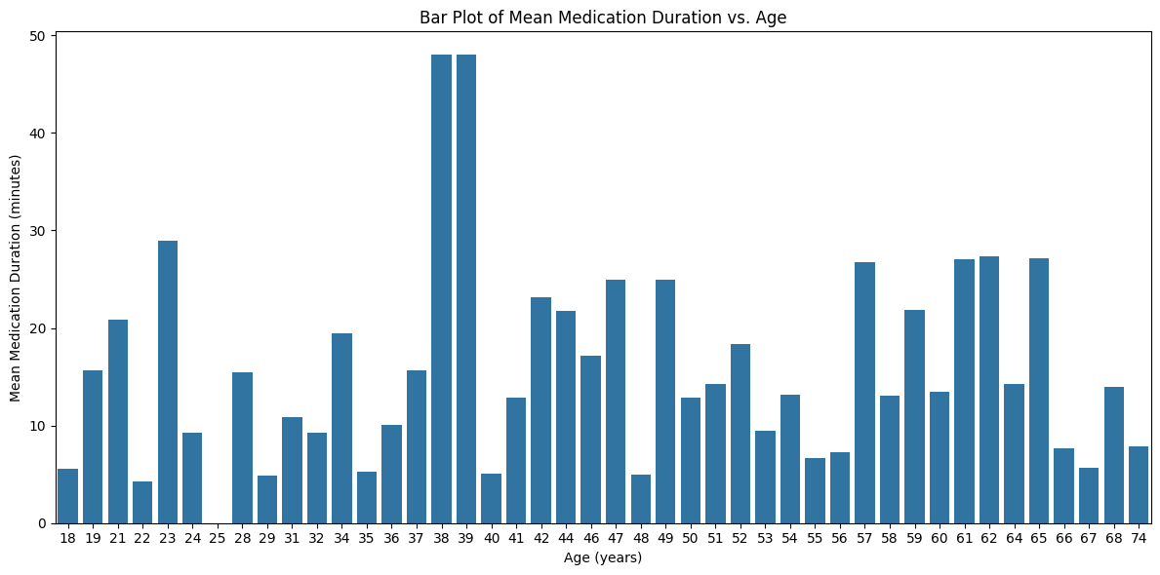

The bar plot depicts the mean medication duration by age group and total opioid dosage. The bars show the average duration of the medication that patients in a particular age group take.

This plot generally illustrates a few prominent trends in medication duration concerning age and opioid use. Generally, the younger the age groups, the shorter the average medication duration, while the oldest individuals had longer medication durations. Furthermore, it is observed that there is a significant rise in the medication duration when the dosage level of opioids is higher. That means high dosages indeed involve more extended medication periods. These findings offer insight into the complexity involved in the management of opioids and need to be considered in terms of age and dosage when determining a treatment plan. Such considerations are essential in improving patient care while reducing some of the risks involved in opioid use.

For this, a boxplot has been used for this visualization because it gives a good summary of the distribution of the opioid dosage data, showing the median and quartiles and potential outliers. This type of plot provides a proper comparison between two groups to show the spread and central tendency of dosages prescribed to males and females.

This illustrates the distribution of total opioid dosage, opioid_total, across male and female subjects. More precisely, it shows that there is a significant difference in opioid prescriptions between genders, with females receiving lower dosages on average compared to males.

This observed difference in opioid prescribing could imply a greater social problem than medical ones. This is because studies show that women are often discriminated against in healthcare facilities, which might subsequently result in the under-treatment of their pain. This perhaps is partially related to societal expectations about the role of genders in that there is a belief that women report more pain emanating from psychological problems compared to physical ones. Secondly, opioid use among women carries some stigma that would impact how health professionals approach pain management for women. All of the speculation just provided does match with the graph, the majority of females recieving MUCH less medication

This all, therefore, points to the following key trends from analysis: patient age, medication duration, and total opioid dosage in the dataset on opioid prescription. The main findings are that the younger the patient, the lesser the length of medication; and higher doses are prescribed for a longer duration of treatment. These observations strengthen the concept of personalized medicine whereby healthcare providers must consider an individual's age and dosage complementary to one another in his or her prescribing behavior. Further research can be done on the long-term outcome of the patients based on various opioid dosages, including dependency and side effects. Most importantly, research into the effects of non-opioid options in treatment regimens may, therefore, offer a glimpse into pain management in a much safer fashion.